**Hyper Text Markup Language**

**15/Feb/2023**

**What is HTML?**

* HTML stands for Hyper Text Markup Language
* HTML is the standard markup language for creating Web pages
* HTML describes the structure of a Web page
* HTML consists of a series of elements
* HTML elements tell the browser how to display the content
* HTML elements label pieces of content such as "this is a heading", "this is a paragraph", "this is a link", etc

**Boilerplate:**

<!DOCTYPE html>  
<html>  
<head>  
<title>Page Title</title>  
</head>  
<body>  
  
<h1>My First Heading</h1>

<br>  
<p>My first paragraph.</p>  
  
</body>  
</html>

Link :- https://github.com/Ishu335/Html/blob/main/Boiler%20Plat.html

**Tags:**

* The <!DOCTYPE html> declaration defines that this document is an HTML5 document
* The <html> element is the root element of an HTML page
* The <head> element contains meta information about the HTML page
* The <title> element specifies a title for the HTML page (which is shown in the browser's title bar or in the page's tab)
* The <body> element defines the document's body, and is a container for all the visible contents, such as headings, paragraphs, images, hyperlinks, tables, lists, etc.
* The <h1> element defines a large heading
* The <p> element defines a paragraph

What is an HTML Element?

An HTML element is defined by a start tag, some content, and an end tag:

<tagname> Content goes here... </tagname>

The HTML **element** is everything from the start tag to the end tag:

<h1>My First Heading</h1>

<br>

<p>My first paragraph.</p>

**Note:** Some HTML elements have no content (like the <br> element). These elements are called empty elements. Empty elements do not have an end tag!

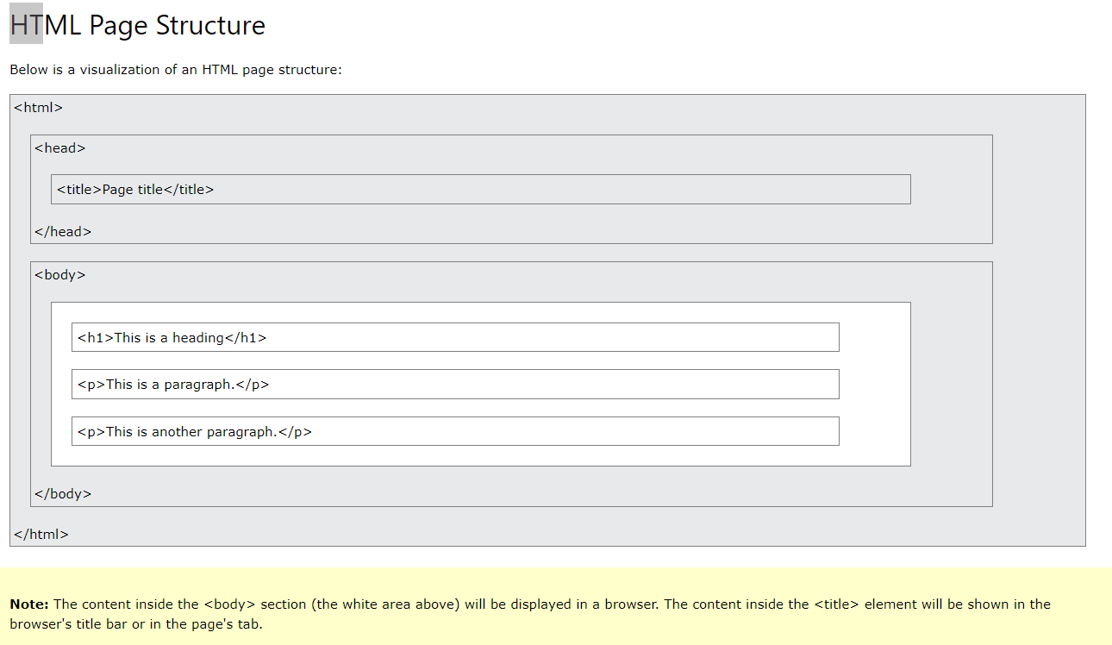

## HTML Documents <Tags> :

All HTML documents must start with a document type declaration: <!DOCTYPE html>.

The HTML document itself begins with <html> and ends with </html>.

The visible part of the HTML document is between <body> and </body>

## The <!DOCTYPE> Declaration

The <!DOCTYPE> declaration represents the document type, and helps browsers to display web pages correctly.

It must only appear once, at the top of the page (before any HTML tags).

The <!DOCTYPE> declaration is not case sensitive.

The <!DOCTYPE> declaration for HTML5 is:

## <!DOCTYPE html>

## HTML Headings

HTML headings are defined with the <h1> to <h6> tags.

<h1> defines the most important heading. <h6> defines the least important heading:

### **Example**

<h1>This is heading 1</h1>  
<h2>This is heading 2</h2>  
<h3>This is heading 3</h3>

## HTML Paragraphs

HTML paragraphs are defined with the <p> tag:

### **Example**

<p>This is a paragraph.</p>  
<p>This is another paragraph.</p>

## HTML Links

HTML links are defined with the <a> tag:

The link's destination is specified in the href attribute.

Attributes are used to provide additional information about HTML elements.

### **Example**

<a href="https://www.w3schools.com">This is a link</a>

## HTML Images

HTML images are defined with the <img> tag.

The source file (src), alternative text (alt), width, and height are provided as attributes:

### **Example**

<img src="w3schools.jpg" alt="W3Schools.com" width="104" height="142">

**Practical Of Html File name :- Link Element.html**

**Link:- https://github.com/Ishu335/Html/blob/main/Link%20Element.html**

## Nested HTML Elements

HTML elements can be nested (this means that elements can contain other elements).

All HTML documents consist of nested HTML elements.

The following example contains four HTML elements (<html>, <body>, <h1> and <p>):

### **Example**

<!DOCTYPE html>  
<html>  
<body>  
  
<h1>My First Heading</h1>  
<p>My first paragraph.</p>  
  
</body>  
</html>

[Try it Yourself »](https://www.w3schools.com/html/tryit.asp?filename=tryhtml_elements)

### **Example Explained**

The <html> element is the root element and it defines the whole HTML document.

It has a start tag <html> and an end tag </html>.

Then, inside the <html> element there is a <body> element:

<body>  
  
<h1>My First Heading</h1>  
<p>My first paragraph.</p>  
  
</body>

The <body> element defines the document's body.

It has a start tag <body> and an end tag </body>.

Then, inside the <body> element there are two other elements: <h1> and <p>:

<h1>My First Heading</h1>  
<p>My first paragraph.</p>

The <h1> element defines a heading.

It has a start tag <h1> and an end tag </h1>:

<h1>My First Heading</h1>

The <p> element defines a paragraph.

It has a start tag <p> and an end tag </p>:

<p>My first paragraph.</p>

## Never Skip the End Tag

Some HTML elements will display correctly, even if you forget the end tag:

### **Example**

<html>  
<body>  
  
<p>This is a paragraph  
<p>This is a paragraph  
  
</body>  
</html>

**However, never rely on this! Unexpected results and errors may occur if you forget the end tag!**

## Empty HTML Elements

HTML elements with no content are called empty elements.

The <br> tag defines a line break, and is an empty element without a closing tag:

### **Example**

<p>This is a <br> paragraph with a line break.</p>

## HTML is Not Case Sensitive

HTML tags are not case sensitive: <P> means the same as <p>.

The HTML standard does not require lowercase tags, but W3C **recommends** lowercase in HTML, and **demands** lowercase for stricter document types like XHTML.

At W3Schools we always use lowercase tag names.

# **HTML Attributes**

HTML attributes provide additional information about HTML elements.

## HTML Attributes

* All HTML elements can have **attributes**
* Attributes provide **additional information** about elements
* Attributes are always specified in **the start tag**
* Attributes usually come in name/value pairs like: **name="value"**

## The href Attribute

The <a> tag defines a hyperlink. The href attribute specifies the URL of the page the link goes to:

### **Example**

<a href="https://www.w3schools.com">Visit W3Schools</a>

[Try it Yourself »](https://www.w3schools.com/html/tryit.asp?filename=tryhtml_attributes_link)

You will learn more about links in our [HTML Links chapter](https://www.w3schools.com/html/html_links.asp).

## The src Attribute

The <img> tag is used to embed an image in an HTML page. The src attribute specifies the path to the image to be displayed:

### **Example**

<img src="img_girl.jpg">

[Try it Yourself »](https://www.w3schools.com/html/tryit.asp?filename=tryhtml_attributes_img_src)

There are two ways to specify the URL in the src attribute:

**1. Absolute URL** - Links to an external image that is hosted on another website. Example: src="https://www.w3schools.com/images/img_girl.jpg".

**Notes:** External images might be under copyright. If you do not get permission to use it, you may be in violation of copyright laws. In addition, you cannot control external images; it can suddenly be removed or changed.

**2. Relative URL** - Links to an image that is hosted within the website. Here, the URL does not include the domain name. If the URL begins without a slash, it will be relative to the current page. Example: src="img_girl.jpg". If the URL begins with a slash, it will be relative to the domain. Example: src="/images/img_girl.jpg".

**Tip:** It is almost always best to use relative URLs. They will not break if you change domain.

## The width and height Attributes

The <img> tag should also contain the width and height attributes, which specify the width and height of the image (in pixels):

### **Example**

<img src="img_girl.jpg" width="500" height="600">

[Try it Yourself »](https://www.w3schools.com/html/tryit.asp?filename=tryhtml_attributes_img)

## The alt Attribute

The required alt attribute for the <img> tag specifies an alternate text for an image, if the image for some reason cannot be displayed. This can be due to a slow connection, or an error in the src attribute, or if the user uses a screen reader.

### **Example**

<img src="img_girl.jpg" alt="Girl with a jacket">

[Try it Yourself »](https://www.w3schools.com/html/tryit.asp?filename=tryhtml_attributes_alt)

### **Example**

See what happens if we try to display an image that does not exist:

<img src="img_typo.jpg" alt="Girl with a jacket">

[Try it Yourself »](https://www.w3schools.com/html/tryit.asp?filename=tryhtml_attributes_alt_error)

You will learn more about images in our [HTML Images chapter](https://www.w3schools.com/html/html_images.asp).

## The style Attribute

The style attribute is used to add styles to an element, such as color, font, size, and more.

### Color:red

Font:new time roman

### text-align:center

### **Example**

<p style="color:red;">This is a red paragraph.</p>

[Try it Yourself »](https://www.w3schools.com/html/tryit.asp?filename=tryhtml_attributes_style)

You will learn more about styles in our [HTML Styles chapter](https://www.w3schools.com/html/html_styles.asp).

## The lang Attribute

You should always include the lang attribute inside the <html> tag, to declare the language of the Web page. This is meant to assist search engines and browsers.

The following example specifies English as the language:

<!DOCTYPE html>  
<html lang="en">  
<body>  
...  
</body>  
</html>

Country codes can also be added to the language code in the lang attribute. So, the first two characters define the language of the HTML page, and the last two characters define the country.

The following example specifies English as the language and United States as the country:

<!DOCTYPE html>  
<html lang="en-US">  
<body>  
...  
</body>  
</html>

You can see all the language codes in our [HTML Language Code Reference](https://www.w3schools.com/tags/ref_language_codes.asp).

## The title Attribute

The title attribute defines some extra information about an element.

The value of the title attribute will be displayed as a tooltip when you mouse over the element:

### **Example**

<p title="I'm a tooltip">This is a paragraph.</p>

[Try it Yourself »](https://www.w3schools.com/html/tryit.asp?filename=tryhtml_attributes_title)

## We Suggest: Always Use Lowercase Attributes

The HTML standard does not require lowercase attribute names.

The title attribute (and all other attributes) can be written with uppercase or lowercase like **title** or **TITLE**.

However, W3C **recommends** lowercase attributes in HTML, and **demands** lowercase attributes for stricter document types like XHTML.

At W3Schools we always use lowercase attribute names.

## We Suggest: Always Quote Attribute Values

The HTML standard does not require quotes around attribute values.

However, W3C **recommends** quotes in HTML, and **demands** quotes for stricter document types like XHTML.

### **Good:**

<a href="https://www.w3schools.com/html/">Visit our HTML tutorial</a>

### **Bad:**

<a href=https://www.w3schools.com/html/>Visit our HTML tutorial</a>

Sometimes you have to use quotes. This example will not display the title attribute correctly, because it contains a space:

### **Example**

<p title=About W3Schools>

[Try it Yourself »](https://www.w3schools.com/html/tryit.asp?filename=tryhtml_attributes_error)

 At W3Schools we always use quotes around attribute values.

## Single or Double Quotes?

Double quotes around attribute values are the most common in HTML, but single quotes can also be used.

In some situations, when the attribute value itself contains double quotes, it is necessary to use single quotes:

<p title='John "ShotGun" Nelson'>

Or vice versa:

<p title="John 'ShotGun' Nelson">